Q3.1

Reference model can be very helpful for tracking an object in video. We can get it out of every image of a book, as we saw previously although 4 points theoretically are enough, we take 6 points to be robust against noise. In the creation of the reference we will use a manual method.

Again, order is important, we had to pick the points in the following order:

* Top left corner
* Top right corner
* Bottom left corner
* Bottom right corner
* Middle of top edge
* Middle of right edge

Examples:

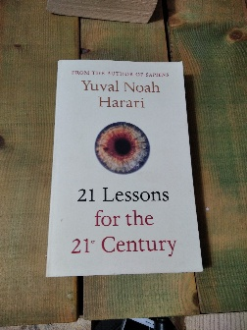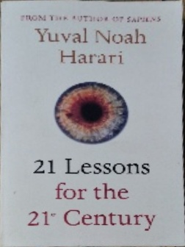

Book 1



Book 2

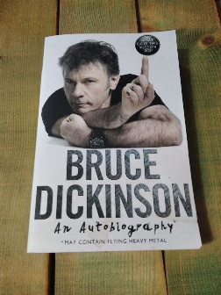

Book 3

Q3.2

Now that we have a reference for a few books we can find them in a real image. We will implement an im2im() function

im2im(base, ref, item) -> img

It gets 3 images as an input

Base – an image with the reference somewhere in it (object), any size (H, W)

Ref – an image of the object we are looking for, any size

Item – an image that we will plant in the base image, any size

It outputs an image

Img – base image with the reference within it replaced with the item, size (H, W)

First the function will run a SIFT algorithm with base and ref, if the ref isn’t occluded in the image and close enough SIFT can easily find and set a matrix to transpose it on it. Once the best matrix is calculated with ransecH (Q2.8) we resize the item to fit ref. Resize in necessary to have the item to cover the object perfectly. Perform wrap on the item with matrix H we found for ref. The new wrapped item is the same size as base image and in the proper place, with a big black background. Lastly, we mask the wrapped item and plant it on the image.

Examples:

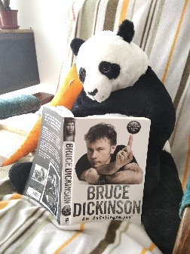

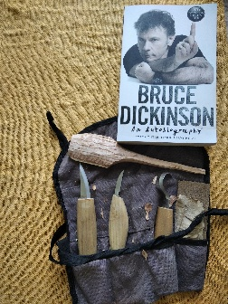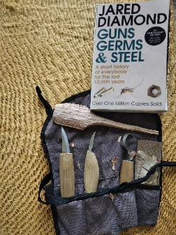

Q3.3

vid2vid(main, ref, side) -> out

main – list of images to main video, length any size (N, H, W)

ref – reference image

side – list of images to be planted in main video, any size (M, a, b)

out – list of planted images, size(min{N, M}, H, W)

Image planting can be done to any image basically, it doesn’t has be another reference image, and it can be done again and again even if the object moves. Using this principle, we can implant a video within a video. It is surprisingly easy, take 2 videos Iterate over both of them simultaneously, and on each pair take the side and plant it in base with the ref and im2im(). There is no reason to change the implementation within im2im() for this function, since each pair are just 2 images. im2im() can get any size of image as input and it resizes automatically so when the perspective on the object changes im2im() can handle it.

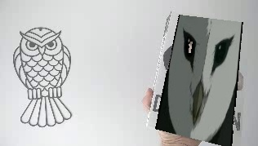

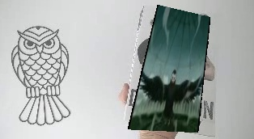

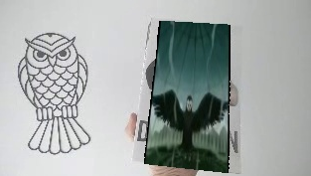

Q3. 4

Same as vid2vid() takes a video into separate images and does im2im() on them, we can take 2 videos that are results of vid2vid() and stitch them together image by image.

This is what we have done, and to make it a little spooky we will implant the right video on the left one and wise versa.